INTR 8016 Project Research Report

Lifestyle Application

Sarah O’Sullivan

BSc.(Hons.) in IT Management

Department of Computing

Student ID: R00069737

Supervisor: Deirdre Dunlea

Second Reader: Noreen Gubbins

Date: 2nd January 2014

Table of Contents

1 Introduction 4

1.1 Overview 5

1.2 Overall Project Goal 6

1.3 Project Objectives 6

1.4 Project Tools 6

1.5 Learning Outcomes 6

2 Project Detail 7

2.1 Medication Section 7

2.1.1 Online Application 7

2.1.2 Mobile Application 7

2.2 Dietary Section 8

2.2.1 Online Application 8

2.2.2 Mobile Application 8

2.3 Exercise Section 9

2.3.1 Online Application 9

2.3.2 Mobile Application 9

2.4 Administrator Section 9

3 Literature Review 10

3.1 Online Application 10

3.1.1 Content Management System (CMS) 10

3.1.2 Types of Content Management Systems 11

3.1.3 Web Content Management System 12

3.1.4 Types of Web Content Management Systems 14

3.1.5 XAMPP 20

3.1.6 Apache HTTP Server 21

3.1.7 MySQL Database 23

3.1.8 PHP 23

3.2 Mobile Application 24

3.2.1 Mobile Application Development 24

3.2.2 Platform Development Environment 25

3.2.3 Mobile Application Testing 27

3.2.4 Advantages & Disadvantages of Using an Android Platform 27

3.2.5 Advantages & Disadvantages of Using a BlackBerry Platform 28

3.2.6 Advantages & Disadvantages of Using an iPhone Platform 29

3.2.7 Advantages & Disadvantages of Using the Windows Platform 29

3.2.8 Market Share 30

3.2.9 Choosing the Best Platform 31

3.2.10 Developing an Android Application 33

3.2.11 Platform Versions 35

3.2.12 Connecting the Android Application to the MySQL Database 36

4 Use-Case Diagrams 38

4.1 Online Application 38

4.2 Mobile Application 39

5 Requirements 40

5.1 Functional Requirements (Online Application) 40

5.1.1 Registration / Login Page 40

5.1.2 Main Homepage 40

5.1.3 Medication Routine 40

5.1.4 Dietary Routine 41

5.1.5 Exercise Routine 41

5.1.6 Administrator Interface 42

5.1.7 Download Mobile Application 42

5.2 Functional Requirements (Mobile Application) 42

5.2.1 Login Page 42

5.2.2 Main Homepage 42

5.2.3 Medication Routine 43

5.2.4 Dietary Routine 43

5.2.5 Exercise Routine 44

5.2.6 Notifications 44

5.3 Non-Functional Requirements (Online and Mobile Application) 44

5.3.1 Look and Feel Requirements 44

5.3.2 Security and Legal Requirements 45

6 Storyboard 45

6.1 Online Application 45

6.1.1 Registration / Login Page 45

6.1.2 Main Homepage 46

6.1.3 Medication Section 47

6.1.4 Dietary Section 47

6.1.5 Exercise Section 49

6.1.6 Administrator Interface 50

6.1.7 Login Page 50

6.1.8 Main Homepage, Medication Section 51

6.1.9 Dietary Section, Exercise Section 52

7 Project Plan 52

8 Project Schedule 53

9 Conclusion 56

10 Bibliography 58

# Introduction

This report contains the project research which I have carried out for the purpose of creating an online lifestyle application which will be linked to a mobile application. The main reason for including a mobile application is for it to serve as a reminder to users in relation to the times in which they should take their specified medicine, the times which they should be eating and the times which they should be exercising. Both applications will be developed with the intention of being used by health-conscious users who would use the application to keep track of their medical, dietary and exercise routines. Originally, I had intended to create the application for medicinal purposes only.

Before I decided to include the dietary and exercise sections to the system, my inspiration for the original project was due to a condition which my aunt suffers from which is called schwannomatosis. This is a form of genetic disorder which is called neurofibromatosis that has only recently been recognised. It consists of multiple schwannomas, which are mostly benign tumours. Although they are benign, they become detrimental when the growing tumour compresses a nerve. She has an extending list of medication which she has to take every day. When she is taking her medication, I have often noticed her confusion regarding which medicine to take and how much of each type of medication she should take.

For this reason, I decided to create an online application whereby users could enter the medication which they are taking along with the amount they should be taking and the time intervals which they should be consumed. The idea was that, due to the online application being linked to the mobile application, the user would be reminded when the medication is due to be consumed. I wanted the reminder to sound an alarm via the user’s mobile device while displaying the name of the medication to be taken and the amount to be taken.

As I investigated further into my project idea, I decided that although this application could be used by many people, as the majority of people have some kind of medicinal prescription, not everyone could benefit from it. Therefore, I decided to investigate other aspects which I could incorporate into the project.

At this point, I decided that in a lot of cases, people who are taking medication also have a dietary and exercise routine which they should be following. In an attempt to broaden the user interest for this application, I decided to ask family members and friends if they would use either the medication, dietary or exercise section of this application if it were to be available. The response I received ensured me that the application was worth developing.

I found that people’s preferences will differ regarding whether they take medication, whether they keep track of their dietary intake or whether they feel the need to exercise. But this application doesn’t require the user to use all three sections. They may only use one of the sections, but either way they are still using the application. Therefore, I think that combining three sections provides users with a choice, which ultimately, makes the application more appealing.

## Overview

This application would be an online lifestyle system which is designed for health-conscious individuals to enable them to keep track of their food and medication intake as well as their exercise routine. The user can sign up to the system via the online application and login using their specified details from their home computer. Once the user is signed up to the system, they can access any of the three available sections of the system.

Firstly, they may access the medication system. Here, they enter their medication details. The mobile application will respond to the time entered for each medication, as this states the time at which it is to be taken.

Secondly, they may access the dietary system. Here, they can select the type of food / drink they consumed as well as selecting the amount consumed. The mobile application will respond to this figure as it will notify the user, with an alarm, when the specified calorie intake, for that day, has been reached.

Finally, the user may access the exercise section of the system. Here, they can enter the overall time spent exercising per entry as well as selecting the type of exercise they did. The mobile application will respond to any reminders set for exercise routines.

The application that the user can download onto their phone allows the user to keep their medication, dietary and exercise routines up-to-date while they are away from their home computer.

## Overall Project Goal

The purpose if this application is to develop a PHP based application that will be run over a network where users can have their prescriptions automatically ordered and to develop a mobile application that users can use on their mobile device. Both the online and mobile applications should allow users to keep track of their medical, dietary and exercise routine on a daily basis.

## Project Objectives

1. Design an online lifestyle system to allow users to sign up to the system, enter details regarding their medical, dietary and exercise routines, save their updates and view / add / edit / remove any details where necessary.
2. Design a mobile application to allow users to view their medical, dietary and exercise routines. It should notify users when medication needs to be taken, when their daily total calorie intake has been reached and when they are scheduled to exercise.
3. Design an administrative application to allow the pharmacist to manage e-mails which have been received to order a prescription and to reply to these e-mails appropriately.

## Project Tools

The project tools which I intend to use when developing my online and mobile applications in the implementation phase are as follows;

* HTML5
* MySQL
* Java
* PHP

## Learning Outcomes

When I have completed the research and implementation phase, I expect to have the following learning outcomes as, by that stage, I will have developed my lifestyle application;

* Development of a Java application on the network
* Development of PHP
* Development of a database using MySQL

# Project Detail

## Medication Section

### Online Application

The user enters their list of medication, the amounts which are to be taken and the time at which each dose should be taken. The user will then be able to mark which medication has been taken. Details of each medication can be added / removed / edited. A link will be provided for each medication listed which will redirect the user to information regarding that specific medication, such as; side effects, general information and whether or not food / drink should be consumed around the time of each dosage.

When the user is running low on a certain medication, an automatic e-mail will be generated stating the user details, the medication type and the amount of which is to be prescribed for the user. This e-mail will be received by the pharmacy and the prescription will be ordered and ready for collection at the user’s convenience. The user has the option of choosing a previous date on a provided calendar which, when selected, will display all medication taken on that day. Also, the user has option of printing off their current / previous medication list.

### Mobile Application

The user can view their list of medication including the amount of each to be taken and the time at which it should be taken. The user will be able to mark which medication has been taken. It will also be possible to add / remove / edit medication. When the user is finished, they can save their updates and it will be sent back to the users account on their online application, which will be automatically updated.

The mobile application will respond to the time entered for each medication, this states the time at which it is to be taken. When this time has been reached, the mobile application will sound an alarm to notify the user that the medication is due to be taken. Also, if the prescription for a certain medication has been used and the pharmacy no longer has a prescription on file in order to give the user the medication, an alarm will sound to notify the user that a doctor’s appointment is necessary to get a re-prescription.

## Dietary Section

### Online Application

The user can select the type of food / drink they consumed as well as selecting the amount consumed. Once this information has been entered, the calorie intake will be automatically calculated for each entry. At the end of a day, the user can click the “Calculate” button to have the total calorie intake calculated. The user has the option of choosing a previous date on a provided calendar which, when selected, will display all dietary intake on that day. Also, the user has option of printing off their current / previous dietary list.

Details of the food / drink intake can be added / removed / edited. A link will be provided to inform the user of dietary guidelines which should be followed for a typically healthy lifestyle. Also, a food pie chart will be displayed based on the protein, carbohydrates, fats and more that the user will have consumed based on their entries. The user can enter the amount of calories they want to allow themselves at the start of each day.

### Mobile Application

The user can view their dietary list including the types of food / drink consumed, the amount consumed and the associated calories with each, as well as the total calorie intake so far that day. It will also be possible to add / remove / edit dietary entries from the list. When the user is finished, they can save their updates and it will be sent back to the users account on their online application, which will be automatically updated.

The mobile application will respond to the maximum calorie intake figure entered on the online application as it will notify the user, with an alarm, when the specified calorie intake, for that day, has been reached. Also, the user can optionally enter reminders for the times at which they should eat and, if necessary, what they should be eating.

## Exercise Section

### Online Application

The user can enter the overall time spent exercising per entry as well as selecting the type of exercise they did. The user has the option of adding / editing / removing an exercise entry. At the end of each day, the user can click a button to have the total amount of exercise on that day displayed.

At the start of each day, the user will be asked to enter the times at which they plan to exercise on that day. This is an optional feature as the user can also enter their exercise routine at random. The user has the option of choosing a previous date on a provided calendar which, when selected, will display all exercise carried out on that day. Also, the user has option of printing off their current / previous exercise list.

### Mobile Application

The user can view their exercise list including the type of exercise they did that day and the amount of time spent exercising. It will also be possible to add / remove / edit exercise entries from the list. When the user is finished, they can save their updates and it will be sent back to the users account on their online application, which will be automatically updated.

If the user chooses to enter times at which they intend to exercise, an alarm will notify the user when they are supposed to begin their exercise routine. This feature is mainly used to enhance the motivation of the user to exercise. Also, when the user is adding an entry, they will enter the start and finish time of their exercise routine and the application will calculate the amount of time spent exercising.

## Administrator Section

The online application will have an administrator interface, which is used by the main pharmacy assistant. The pharmacy assistant will login and manage any e-mails which have been received via the application regarding the collection of the next dosage for the user. The pharmacy assistant will prepare the prescription so that it is ready for collection, depending on whether a prescription is on file for the listed user and medication type. An e-mail will be sent back to the user’s account informing the user that their prescription is ready for collection.

# Literature Review

## Online Application

### Content Management System (CMS)

#### What is a Content Management System?

1A CMS is a computer program which allows a user to publish, edit and modify content while also allowing the user to control the system using a main interface. It allows a user to handle workflow using basic procedures. Depending on the user preference, these procedures can be manual or automatic. Typically, a CMS would be used to create websites which incorporates a shopping interface, news and / or blogs. In general, they are used to avoid the need for writing code but they also provide support for hand-written code for an entire webpage or for specific elements throughout the website.

The primary objective of a CMS is to allow for information to be presented on a website. But, the overall features of a CMS can vary depending on the activity which is expected from the functioning website. A simple system would provide the user with a small amount of basic features, whereas, complex systems would provide the user with more powerful and effective features. A typical CMS would consist of; web publishing functions, format management, revision control, indexing and the ability to search and retrieve information.

Depending on the type of content the user wants to display on the website, different types of CMS’s can be used. The kind of content to be shown will indicate which type of CMS to be used, for example, the user may require videos or specific graphics to be displayed. In any case, there are a variety of options available to the user to enable them to find a CMS which will cater for all their requirements. There are four types of CMS’s which are widely used, these include;

1. Web Content Management System (WCMS)
2. Enterprise Content Management System (ECMS)
3. Mobile Content Management System (MCMS)
4. Component Content Management System (CCMS)

### Types of Content Management Systems

#### Web Content Management System

2A WCMS provides a user with the ability to create or alter a webpage regardless of whether the user has the necessary technical skills that would be required if they were to develop the website without the assistance of a CMS. It consists of a selection of templates which are combined in order to create a website structure which can ultimately be used for creation of the content. The user, who would at this point be known as the “editor”, can then simply enter their content into the provided templates and it will be automatically published onto the website. WCMS’s tend to be used for internet websites, extranets and intranets.

#### Enterprise Content Management System

An ECMS is generally used to represent the formation and hierarchy of an individual organisation. It allows a user to carry out these activities by handling the content, assets, records and other data related to the organisation. It is more complex than a WCBS as it handles a variety of processes, methods and tools. Its primary purpose is to manage confidential information for a specified company, such as their documents and other content.

#### Mobile Content Management System

Due to the vast development in the mobile technology industry, users began to require a CMS which can be used on devices such as; mobile phones, smartphones and many other handheld devices. This system is currently being used in the business to business and the business to employee markets, although the original MCMS design was developed for the business to customer market. The functionality of the MCMS allows the user to store and deliver content and services. As well as existing as a stand-alone system, a MCMS can be used in the form of features, modules or add-ons of a more complex CMS which is capable of delivering multi-channel content.

#### Component Content Management System

This a special type of CMS which handles the displayed content at a more complex level. This mainly relates to an individual section of content, for example, a text paragraph or a single graphical image. This section of content, which exists within the system, is reused throughout a document or a selection of documents to provide consistency. In relation to the specific section of content, it has its own individual workflow and is maintained as part of the overall system or as single entity.

#### Online Lifestyle Application – Which type of CMS?

As I am developing an online website where I intend to display content, while also writing my own code in order to design the medication, dietary and exercise sections according to my personal specifications, I plan to use a Web Content Management System. I have had previous experience with a few WCMS’s which I hope will be beneficial during the creation of the website. I will be using a WCMS to create, manage and edit my website at a considerably easier level than if I was to develop the website from scratch by writing the HTML, CSS and Javascript code. Although, I feel I would be capable of doing this, I don’t think I would have enough time to complete the project if I were to write all of the code. For this reason, I will be writing sections of the code myself, and implementing the code into the required sections throughout the website as necessary. Also, these CMS’s allow for code to be written once while also allowing it to be used multiple times in other sections. This is a useful attribute in the development of my website as I have three sections, which in some cases, can have similar features which would present similarities in their code.

### Web Content Management System

#### Types of Web Content Management Systems

In relation to WCMS’s, there three main types which include;

1. Offline Processing Systems

This type of system processes the content, which is entered by the editor, before the website goes live.

1. Online Processing Systems

This type of system depends on content which is generated by the user, for example, blogs and forums.

1. Hybrid Systems

This type of system combines aspects of an offline processing system and an online processing system to create a system where the editor enters content, while content is also generated by users of the webpage.

To develop my website, I will be using an offline processing system as I, the editor, will be entering the content before the website goes live. When the website goes live, I do not intend to have user-generated content in the form of blogs or forums, to be displayed on the website. The information that is entered by the users will be personal and should only be viewed by them. Other users should not be able to access or view their data input. Each user will have to begin by creating an account and each time they wish to access their account they will be required to login, preventing others from accessing their data.

#### Advantages of using a WCMS

There are many advantages linked to using a WCMS, these include;

* A cross-linking feature is provided which allows the user to navigate throughout the website without the need to use the navigation bar.
* Content which is published can be made available to the user as soon as the editor requires as long as the location where the information is being published has access to a Wi-Fi connection.
* Changes to the content published on the website can be easily tracked and altered to reflect the old information if required.
* Published information can be re-used in many devices, such as, mobile phones.
* The information displayed on the website can be easily controlled.
* The website can be developed easily to have a professional look and feel.
* In relation to Search Engine Optimisation (SEO) purposes, it allows search engines to have easy access.
* It provides the user with an improved experience as well as an easily accessible interface.

### Types of Web Content Management Systems

#### Joomla

3Joomla is a well-known, widely-used content management system. It allows the user to create websites and useful applications online. There are many factors incorporated into Joomla that make it a system which is flexible and easy to use, these factors have made Joomla one of the most favoured available pieces of software for developing websites today. In addition, it is available to users as open-source software which is freely accessible to everyone.

Currently Joomla is used in many parts of the world to produce websites; whether they are small and basic or large and complex. Examples of situations where Joomla is being used include;

* Business’s portals or websites
* Both intranets and extranets in relation to a business
* Applications which are provided by the government
* Organisational websites
* Personal homepages

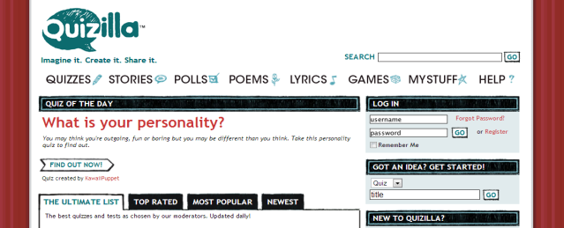To provide an example of the variation of websites which were developed using Joomla and can be located on the internet, I have listed three websites, each with a different overall purpose, and their corresponding URL’s;

1. A Social Networking website

MTV Networks Quizilla ()

This is a website which allows a user to create quizzes, surveys, polls, stories and more.

1. An Educational website

Harvard University ([http://gsas.harvard.edu](http://gsas.harvard.edu/))

This is a website which allows prospective students of the university to search available courses and apply for them. It also provides general information about the university itself.

1. 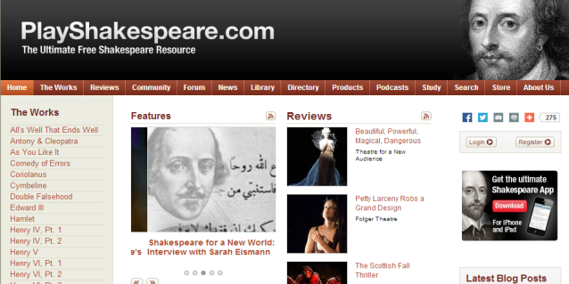A Cultural website ([http://www.playshakespeare.com](http://www.playshakespeare.com/))

This is a website which provides users with resources based on Shakespeare. These resources include; reviews, forums, documents and plays.

Due to the way in which Joomla has been developed, it is very easy to install and use, even for people who may not necessarily have a technological background to support them. For a web developer, which is the role I will be taking for this project, websites can be created relatively quickly. There are a variety of extensions which can be used to allow for specialised functionality.

#### Wordpress

4Wordpress is generally used as a blogging tool, but it can be used for other purposes as well. It has been a basis for many websites currently available on the internet. It is open source software which allows it to be freely available to all users. The software itself, once downloaded and installed, can be customised to the specifications of the user. A service called WordPress.com is also available, which allows you to quickly create a new blog, but to obtain flexibility in the creation of a website, downloading and installing Wordpress would remain the best option.

When Wordpress was originally being created, its main purpose was to be used as a blogging system, but over the years, it has been continuously developed and is now being used as one of the most popular content management systems in the world. With the additional assistance of the widgets, themes and plugins which can be introduced within the system, based on the user’s preferences, Wordpress can be altered to produce a fully-functioning website.

Below, I have outlined three websites and their URL’s which are available on the internet at the moment that were created using Wordpress. By viewing the screenshots, you can see the alterations that can be made to the original Wordpress download to ensure the website looks as the user expected it to;

1. A Blog website (<http://politicalticker.blogs.cnn.com/>)

This is a website which provides users with the latest political news and behind-the-scenes reports, while also allowing them to take part in blogs regarding the outlined news.

1. 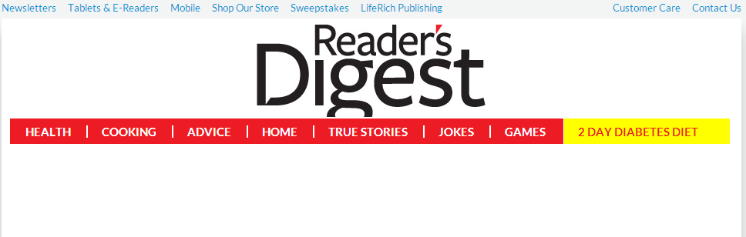A News website (<http://www.rd.com/>)

This is a website which covers many areas from food and health to money and people; it provides users with simple, time-saving tips to help improve their lifestyles.

1. 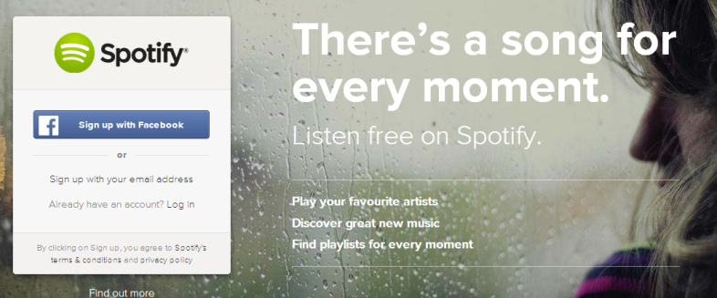A Technology website (<http://www.spotify.com/>)

This is a website which provides users with access to millions of songs in order for them to download songs, create playlists or simply just search for a specific song.

In general, Wordpress is commonly known for its ease of installation. It can be done by following very few simple steps and takes a short amount of time to complete. Before installing Wordpress, there are a few steps which should be completed which include; gaining access to your web server, a text editor, an FTP client and a preferred web browser.



#### Drupal

5Drupal is another open-source software package which allows users to easily manage, publish and organise their content. It allows a level of customisation to provide the user with the opportunity to create a website which meets their necessary requirements. Anyone can download Drupal and share it with others. Due to the open development model that exists with Drupal, it is constantly being updated to ensure that the platform supports all of the latest technologies available at all times. The Drupal content management system complies with specific standards and it ensures an easy to use system is available to its clients.

Drupal provides its users with many features including;

* Organise and Find

It provides the user with tools to help them organise, find and re-use content which has already been published, as well as the ability to create easy-to-read URL’s and make an association between related content on the website.

* Creative Content

It is a flexible system which allows a user to publish a variety of content such as; text, videos, blogs and polls.

* Extensions

The Drupal site can be extended by using the wide range of available add-on modules.

The popularity of Drupal as a content management system has grown rapidly over the past few years. I researched websites which have been developed using Drupal and I found there were hundreds of results, I chose three of these and have outlined them below;

1. 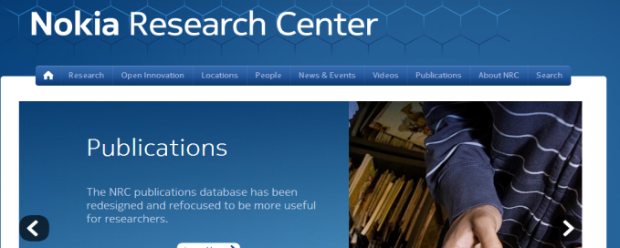A Corporate Website (<https://research.nokia.com/>)

This is a website which is based on the research carried out by Nokia. It includes information about their people, news, events and more.

1. An Educational Website

(<http://duke.edu/>)

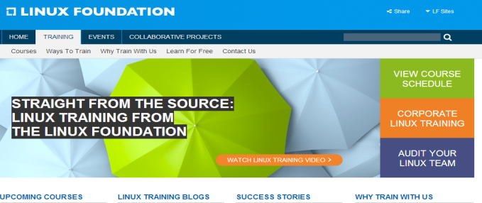This is a website which provides general information about Duke University. It also provide links which allow a student to submit and view their admissions.

1. A Non-Profit Website

(<http://www.linuxfoundation.org/>)

This is a website which allows users to view information about Linux in general, their training courses, the events that they are holding and the collaborative projects they are undertaking.

#### Which WCMS will I use for my website?

I have chosen to use Joomla as the Content Management System which will assist the creation of my online lifestyle website. I have had experience in using all three CMS’s which I have previously outlined. From my experience, the CMS which would be most suitable for the purpose of my project is Joomla.

The advantages of using Joomla are as follows;

* Easy Installation

The steps to be taken when installing Joomla are quite basic; overall, it would take roughly about ten minutes from the point of downloading Joomla to having a functioning script on the server. Although it is not as easy as Wordpress to install, it is much easier than Drupal.

* Extended Features

There are a variety of plugins on the Joomla homepage which can be used. Although Wordpress is known to have more plugins than Joomla, you would have to install many of these plugins at the beginning to provide the functionality which Joomla has to start with.

* Supporting Information

There are a selection of programming tools and step-by-step tutorials which are available to the users of Joomla. A discussion board is also provided for any queries users may have.

The disadvantages of using Joomla are as follows;

* Paying for Plugins

Unlike Wordpress and Drupal, some of the plugins that are available to users for Joomla must be paid for to enable the user to benefit from them.

* Compatibility of Plugins

Some of the plugins which you may install can suffer from compatibility issues. These compatibility issues may require changes to the PHP code in order to get them working.

* User Abilities

Joomla is more suitable for users that have a technological background rather than users with no previous technology experience.

The recommended requirements for installing Joomla are outlined below;

|  |  |
| --- | --- |
| **Software** | **Recommended** |
| PHP | 5.4+ |
| **Supported Databases** |  |
| MySQL | 5.1+ |
| MSSQL | 10.50.1600.1+ |
| PostgreSQL | 8.3.18+ |
| **Supported Web Servers** |  |
| Apache | 2.x+ |
| Nginx | 1.1 |
| Microsoft IIS | 7 |

* From the above list, I intend to use PHP (Version 5.4), MySQL (Version 5.5) as my database and Apache (Version 2.4) as my web server.

### XAMPP

#### What is XAMPP?

XAMPP is a cross-platform web server solution stack which is free and open-source. It contains the following components;

* Apache Web Server
* MySQL Database
* PHP Programming Language
* Perl Programming Language
* SMTP Server
* FTP Server

#### Why use XAMPP?

18It is not an easy task to install an Apache Web Server and the process becomes even more difficult when you intend to add MySQL, PHP and Perl. Therefore, the main beneficial feature of XAMPP is that this installation process becomes simplified. By using XAMPP, the user is not required to install each specific component of a web server individually. For this reason, not only does the installation process become easier but, it also becomes quicker. If a user was to install these components individually, factors would have to be considered such as PHP configuration and the setup of MySQL. Whereas, by using XAMPP, the user does not have to worry about these factors as they are completed automatically.

By opening the necessary ports on the computer’s firewall, the user can run the web server on XAMPP allowing them to serve websites and website applications. The package can be easily installed by following the outlined steps on the apache friends’ website.

19For the development of my website, I intend to download and install version 1.8.2 of XAMPP which includes;

* Apache 2.4.7
* MySQL 5.5.34
* PHP 5.4.22
* phpMyAdmin 4.0.9
* OpenSSL 0.9.8
* XAMPP Control Panel 3.2.1
* Webalizer 2.23-04
* Mercury Mail Transport System v4.62
* FileZilla FTP Server 0.9.41
* Tomcat 7.0.42
* Strawberry Perl 5.16.3.1 Portable

### Apache HTTP Server

20Apache HTTP Server is a well-known standard which assists users in distributing website services. It is an open-source software project, which provides websites with the ability to be available online. It has been developed to serve a variety of commonly-used operating systems such as Linux, Windows, Mac OS X and Solaris. It has been the most popular web server available on the internet since April of 1996.

The Apache Software Foundation, which is an open-source community, developed the Apache HTTP Server. The participants of this community are continuously increasing the amount of helpful functionalities that are available on the server itself, as the introduction of new versions of the server are made available to users. The main purpose of these functionalities is to ensure that a server platform, which is secure and extensible, is provided to users. This platform allows for HTTP service delivery which is in line with present HTTP standards.

There are a range of modules which have been developed to be used with the Apache Server. These modules support many scripts and enable dynamic content to be run on the server. The majority of these modules are incorporated into the Apache software distribution; this allows the server to provide a large amount of capabilities to its users. An example of one of these modules includes; support for CGI (Common Gateway Interface), which is a recognised protocol used for external application software to communicate with a web server. If they wish, users can choose to install any of the available modules during the Apache server installation. Alternatively, they could install them later by using dynamic modules.

#### What are the available versions of the Apache Server?

* **Apache 2.0.65**

21This version of the Apache web server is the last security and bug fix release of the 2.0 version family. But, this does not mean that all security issues are avoided. The developers of Apache recommend that all users should migrate to the stable version of Apache, which is version 2.4 or, alternatively, the legacy version of 2.2.

* **Apache 2.2.26**

This version is an important release for the 2.2 version family. It has additional features than that of the 2.0 version family. These features include;

* Smart Filtering
* Improved Caching
* AJP Proxy
* Proxy Load Balancing
* Graceful Shutdown Support
* Large File Support
* Refactored Authentication
* **Apache 2.4.7**

This version is an important release for the 2.4 version family. It is currently the latest and best version of the Apache web server that is available. It also has additional features such as;

* FastCGI Proxy
* New Expression Parser
* Dynamic Reverse Proxy Configuration
* Loadable MPM’s

As stated above, I am downloading and installing XAMPP 1.8.2. Therefore, I will be using Apache version 2.4.7 as this is the latest, most up-to-date version and it is incorporated into the XAMPP 1.8.2 package.

### MySQL Database

22A MySQL Database is a web hosting database; it is used to save information from a website, for example, user information. It is known as a relational database and is the most popular type of its kind that is used today. This may be slightly due to the fact that it can be used for free, but aside from this, it is also known to be extremely powerful.

This type of database can store any type of information required. It allows a user to store and retrieve information at a relatively fast rate. In addition, many users that are using the website can be using the database simultaneously. SQL statements are used to carry out these actions.

For the creation of my website, I will be using Joomla as my web content management system which was previously discussed. It is popular for a MySQL database to be used in combination with Joomla. The MySQL database which I will be using is MySQL 5.5.34 as this is included in the XAMPP package.

#### phpMyAdmin

When a user is trying to manage a MySQL database, it can be quite difficult to maintain using SQL statements. To simplify the management process, a Graphical User Interface (GUI) can be used. The most popular GUI that is used for managing a MySQL database is phpMyAdmin, which is a web-based application. By using phpMyAdmin, a user can add, remove and maintain databases, tables and entries, easily backup the database, run SQL queries, search records and much more.

For the development of my website, I will be using phpMyAdmin version 4.0.9 as this is included in the XAMPP solution stack.

### PHP

23PHP is a general-purpose scripting language that is especially useful for web development as it can be used to enhance webpages. It is a server-side scripting language as the PHP code doesn’t get executed on your computer but, on the computer which the user requested the page from. The results are then retrieved and displayed on your browser.

Versions of PHP which are freely available to download include;

* **PHP 5.4.22**

When the availability of this version was announced, it was outlined that 10 bugs had been recognised and fixed. One of these bugs was a security issue which was discovered in the OpenSSL module. It is recommended that users should upgrade to this version.

* **PHP 5.3.28**

When the announcement of this version was made, it was outlined that two security issues in the OpenSSL module had been removed.

* **PHP 5.5.7**

This version managed to fix some bugs that were noticed in version 5.5.6. All users are recommended to upgrade to a newer version of PHP rather than to remain using this version.

For the development of my website, I will be using PHP 5.4.22 as this is incorporated into the XAMPP package which I intend to download and install.

## Mobile Application

### Mobile Application Development

#### What is Mobile Application Development?

6Mobile Application Development is a procedure which involves developing application software for mobile hand-held devices. During the manufacturing process of the phone, these applications may have been pre-installed. In other instances, they could be downloaded from the many mobile software distribution platforms by the consumers themselves or they could be provided to the user as web applications by making use of client-side or server-side processing in order to deliver a similar application-like effect via an internet browser.

Developers have to take a lot of aspects into consideration due to the extent of the competition in the mobile software sector of the market and the ever-changing platforms involved, these aspects include; the variation of screen sizes required, configurations and hardware specifications.

In relation to job creation and revenues, there has been a considerable growth in the mobile application development category. According to an analyst report carried out for 2013, the estimated amount of application economy jobs within the European Union has reached around 530,000; it has been recorded that 60% of these jobs are in relation to mobile application developers.

### Platform Development Environment

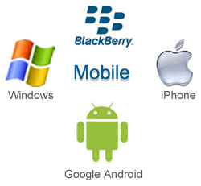There are many platforms available for the development of mobile applications, and each of these platforms incorporates an integrated development environment. These environments support the developer by providing them with tools which, in turn, allow the developer to write, test and deploy an application into the specific platform development environment.

I have chosen four platforms, which I am most familiar with, to investigate in relation to the components which are incorporated into each of their development environments. These platforms include; Android, Blackberry, iPhone and Windows. This information will be displayed below, in the form of a table. I expect that my reason for selecting a particular development platform will be based on my personal preference in relation to each platform and the development skills which I have obtained over the last few years in college.

#### Platform Development Environment Table;

|  |  |  |  |  |  |  |  |
| --- | --- | --- | --- | --- | --- | --- | --- |
|  | **Programming Language** | **Debuggers Available** | **Emulator Available** | **Integrated Development Environment Available** | **Cross-Platform Deployment** | **Installer Packaging Options** | **Development Tool Cost** |
| **Android** | Java (some code can be in C or C++) | Debugger is included in Eclipse, standalone debugging is available | Yes | Eclipse, IntelliJ IDEA, Project Kenai Android plugin for NetBeans | Android Only because of Dalvik VM, March 2009 | apk | Free, IntelliJ IDEA Community Edition - Free |
| **BlackBerry** | Java | Debugger included in IDE | Yes | Eclipse, Blackberry JDE | BlackBerry only, because of RIM API | alx, cod | Free |
| **iOS SDK** | Objective-C | Debugger included in Xcode IDE | Bundled with iPhone SDK, integrated with Xcode IDE | Xcode, AppCode | iPhone, iPad, iPod Touch | Only via App Store, needs review and approval by Apple Inc | Apple tools are free for an Intel-based MAC. Testing is free, but you need to pay to install it on a device. |
| **Windows Phone** | C#, Visual Basic, C, C++ | Yes | Free emulator, also bundled with IDE | Visual Studio 2012, Visual Studio 2010 | Windows Phone | OTA deployment, XAP files | Free |

### Mobile Application Testing

Within the development environment, an emulator is used to test a mobile application. But when the application is believed to be complete, it is subjected to field testing. By using emulators, the developer is provided with an inexpensive method to use in order to test the applications on the mobile phones which the developer may not be able to get access to. There are a variety of tools available to developers which can be used to test an application on the most commonly used mobile operating systems. These tools include;

* Google Android Emulator

This emulator is used for testing Android applications; it is developed to run on a Windows PC without the need for downloading and installing the whole Android SDK package.

* Android SDK Emulator

This package incorporates a mobile device emulator that imitates the collection of hardware and software features that are included in a standard mobile device, without the ability of making a phone call.

* MobiOne

This was developed to run on Windows and it is a mobile Web IDE. It assists a developer in coding, testing, debugging, packaging and deploying mobile web applications to mobile devices including the Blackberry, iPhone and Android.

* iPhoney

This can be used when developing websites for the iPhone.

### Advantages & Disadvantages of Using an Android Platform

#### Advantages

* 7The Android Platform is user-friendly and straightforward because it uses java as a programming language and this tends to be simple to learn.
* The Android Applications Platform has gained the overall trust of its users as it is now completely free from errors and bugs.
* It is suitable for all types of application development whether it be used to develop security, entertainment, business or web-based application and many more!
* Android’s SDK has been updated so that it will automatically locate bugs in the code and test the application.
* Android’s SDK offers the user excellent features which are built-in and it provides a lot of flexibility when developing mobile applications.

#### Disadvantages

* 8When you have developed an Android mobile application you may find that it does not run on all of the Android devices available. It has become very difficult to develop an application which runs on all Android devices and looks presentable on all of the variations of screen sizes.
* There are many versions of the Android operating system available today, in some cases, an application which may run perfectly on a device using one operating system, may crash a different operating system on another device.
* Piracy can be an issue with Android applications due to the fact that it is open-source. This makes especially simple to pirate.

### Advantages & Disadvantages of Using a BlackBerry Platform

#### Advantages

* 9Applications that are developed in a BlackBerry environment allow for a great deal of flexibility. This flexibility allows the application to be platform independent.
* You can synchronise, retrieve and backup data to and from your PC easily.
* It provides effective and constructive tools to assist the developer to create an application easily.
* It provides supports to a variety of frameworks, for example, JQuery and DoJo, this vastly improves the adaptability and effectiveness of the applications.
* BlackBerry allows developers to leave applications running in the background. The applications which have already been developed can be linked with other applications.

#### Disadvantages

* 10The BlackBerry device can tend to be quite slow when responding to web browsing requests; this means that users may have a waiting period before graphics which are included in the application will appear.
* There is a lack of BlackBerry applications in the BlackBerry World application store. This proves that the BlackBerry platform has not been as popular as other platforms.
* BlackBerry originally concentrated on the development of applications and devices to be used for business purposes, for this reason, although BlackBerry has tried to diversify, their platform is not used by a wide audience.

### Advantages & Disadvantages of Using an iPhone Platform

#### Advantages

* 11Generally, Apple users tend to spend a lot more money on applications compared to other platforms.
* Apple consists of a controlled, secure environment. The have their own ecosystem containing the likes of iCloud, iTunes, Xcode and many more, this allows developers to share data easily between the different Apple devices.
* Apple’s IDE provides many features which offers the developer assistance in developing an application, for example, a graphical interface builder.
* Due to the fact that Apple has a consistent brand-name which reflects on it as being a remarkable technological electronic goods provider, when a person downloads an application which you have developed, they already expected it to be a great application.

#### Disadvantages

* The iOS applications will only run on products developed by Apple, therefore, you are unable to take advantage of the variety of features which are available for non-iOS products.
* In relation to market growth, the Android market has grown at a faster rate than iOS.
* The approval process which has to be carried out before your application can be uploaded to the Apple Store can be very time-consuming.

### Advantages & Disadvantages of Using the Windows Platform

#### Advantages

* 12Microsoft plans to make sure that Windows Phone 8 applications handled like “Live Apps”. This will provide a way to connect applications to areas that are most commonly known to be popular with customers.
* The Windows 8 phone has a lock screen, at the top there is a rotation display of the user’s favourite applications, and the lock screen would be useful for developers to remind them of what applications are installed.
* There is room for discoverability as Microsoft is hoping to attract many of the top applications to its platform; this increases the chance of a developers application being easily found or being presented as a featured application.

#### Disadvantages

* Windows Phone platform is not as commonly used as Android and iPhone platforms.
* The Windows Phone market sales are very low and don’t seem to be increasing at a fast enough rate to consider developing an application for a phone that hardly anyone uses!

### Market Share

13On the 12th of November 2013, the sales estimates for the third quarter in relation to market share were made available by IDC. Below, I have created a pie chart to illustrate the market share between Android, BlackBerry, iPhone, Windows Phone and others.

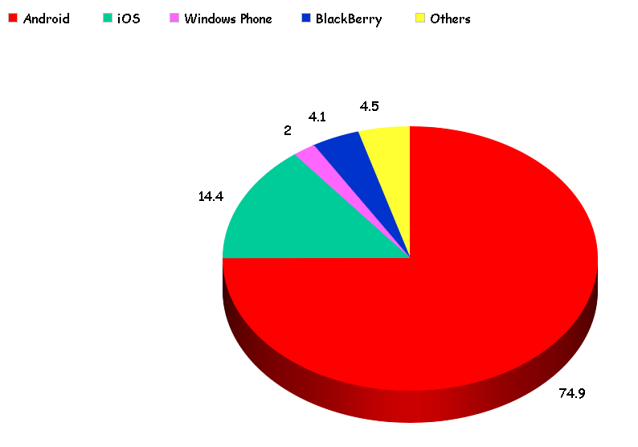

Due to the popularity rate of Google’s Android and Apple’s iOS and taking the outlined advantages and disadvantages into consideration, I have decided to eliminate BlackBerry and Windows Phone as potential platforms for the development of my lifestyle mobile application. From this point onwards, I will focus on investigating which platform would be most beneficial to use for my application between Android and iPhone.

### Choosing the Best Platform

When creating a mobile application, the first step is to decide on the operating system which you intend to use in order to develop your application; Google’s Android or Apple’s iOS? Although there are many other mobile platforms available for developers to use today, such as; BlackBerry, Windows Mobile, Symbian, Qualcomm BREW and Sun J2ME, the most popular platforms seem to be Android and iPhone.

In relation to the smartphone section of the market, the combination of Google’s Android and Apple’s iOS covers almost 90% of the market share. This figure alone proves that they are the most commonly used platforms to date. When Yahoo and Twitter are taken into consideration, we can see that they chose to use Apple’s iOS to develop their mobile applications. However, Google’s Android is currently the leading platform in the smartphone category.

Given the above information, I still have to choose a platform which I feel would be more suitable in the development of my lifestyle mobile application. Below I have outlined three elements which I expect will influence my decision;

#### Hardware & Software

Hardware, without doubt, remains the main differentiator between Apple and Android. The software incorporated into the chosen smartphone will have a big influence on how the device is used as this outlines how the phone will function. In relation to the iPhone, the user interface remains the same, regardless of the model you have.

In contrast, Android has been designed to enable the chosen manufacturer to modify the device before it is released into the market. After these modifications are made, the look and feel of the Android can be dramatically altered.

The Apple iOS is recognised for its highly-applauded user interface, but, if you are not consumed by the interface which the iPhone offers then it is likely that you will find something more suited to your preference by searching through the extensive selection of Android smartphones.

#### Programming Languages

Android mobile applications are developed using the programming language Java. Therefore, if you are familiar with Java, Android could prove to be the most suitable platform for you to develop your application. However, if you would be more comfortable developing a mobile application using Apple’s Objective-C, then it would make more sense to choose Apple’s iOS to develop the application. In general, developers who are accustomed with the programming languages C and C++ would most likely find Objective-C an easier language to learn.

#### Learning Resources

Apple assists application developers by making information regarding the development process available in a variety of ways. A software developer from MAKE Technologies stated that “Important concepts are explained in videos, which makes grasping concepts easy”.

On the other hand, Android provides support for open-source applications which makes sample applications and various other programs advantageous to learn from.

#### Google’s Android or Apple’s iOS?

For the development of my lifestyle mobile application, I have decided to use Google’s Android platform. The reasons as to why I chose Google’s Android platform are as follows;

* Personally, I have always preferred Android mobile technology, in comparison to the technology developed by Apple.
* I have had no previous experience in programming using C, C# or C++; this would immediately indicate that I would have to learn the basis of these programming languages before I could begin to interpret the Objective-C programming language which is used to develop iPhone applications.
* In my previous four years in college, although I have not had a class which focused primarily on Java, I have experienced using this programming language combined with others. Therefore, it should not be an impossible task to study Java in depth in order to create my application.
* Personally, I would like to learn Java as it is a commonly used programming language which would be beneficial to use in future ventures.
* Due to the open-source software, there is a remarkable amount of assistance that can be sought when having issues in relation to the development of an Android application.
* The Android market seems to be increasing faster than that of the Apple market.

### Developing an Android Application

#### Java Software Development Toolkit (SDK)

14A Java Development Toolkit is a development environment which is used when creating Java applications. It incorporates a runtime environment which runs on top of the device’s operating system. In addition, it contains the programming and tools which are required by application developers to compile, debug and run applications which have been developed using the Java programming language. In order to create my lifestyle mobile application, I will need to download the Java Software Development Toolkit.

#### Eclipse Integrated Development Environment (IDE)

15Eclipse is an Integrated Development Environment which consists of a main workspace for creating Java applications and it encompasses methods which allow the developer to customise the environment using a plug-in system. Although Eclipse is mostly used for the development of applications which are written in Java, it also has the ability to assist the creation of applications which are written in a range of other programming languages such as C, C++ and PHP. Users are provided with the opportunity to install plug-ins which have been designed to function within the Eclipse Platform. Also, they have the option of writing and adding their own plug-in modules if necessary. Eclipse is an open-source IDE.

The main goal of the Eclipse IDE is “to develop a robust, full-featured, commercial-quality industry platform for the development of highly integrated tools”. The Eclipse Consortium was created in order to manage and control the continuous development of the tool itself. It concentrates mainly on three specific projects which are;

1. The Eclipse Project

This focuses on the development of the Eclipse platform which is used to host the wide variety of tools associated with the environment. Furthermore, it controls other aspects which are used to extend the platform such as; the Java Development Tools (JDT) and the Plug-In Development Environment (PDE).

1. The Eclipse Tools Project

This is responsible for producing the best-possible tools which are to be used within the Eclipse platform.

1. The Eclipse Technology Project

This concentrates on carrying out technology research and education by using the Eclipse platform.

Many of the features which are integrated into a typical commercial quality IDE are offered to an application developer using Eclipse due to the combination of the Eclipse platform and the JDT. But, it also contains some distinctive characteristics like code refactoring and a task list. A particular factor which makes the Eclipse IDE unique is its recognition as being completely platform and language neutral. The plug-in ability of the platform itself and the provided Application Programming Interfaces (API) gain particular interest from developers in relation to their ability to extend the platform as required.

In order to enable the development of my mobile application, it will be necessary to download the Eclipse IDE.

#### Android Software Development Toolkit (SDK)

16The Android Software Development Toolkit contains a collection of development tools which are required when developing an application which is to be creating on the Android platform. It incorporates many tools such as;

* A Debugger
* An Emulator
* The Required Libraries
* Related Documentation for the Android API’s
* Sample Source Code
* Tutorials for the Android Operating System

When a new version of Android is released, an SDK related to this new version is also released. The SDK must be downloaded and installed for each version in relation to the specific phone in use to enable the developer to write programs which contain the latest features.

For the development of my mobile application, I will be required to download the Android SDK which corresponds to the version of Android I intend on using.

### Platform Versions

17The below data includes versions of Android from 2.2 and above, this is because it was collected via the new Google Play Store application which only supports Android 2.2 and above. Therefore, devices which may be running an older version are not included in the presented data. Yet, in August of 2013, versions which are older than this made up about 1% of the devices which checked into Google’s servers rather than the devices which accessed Google’s Play Store.

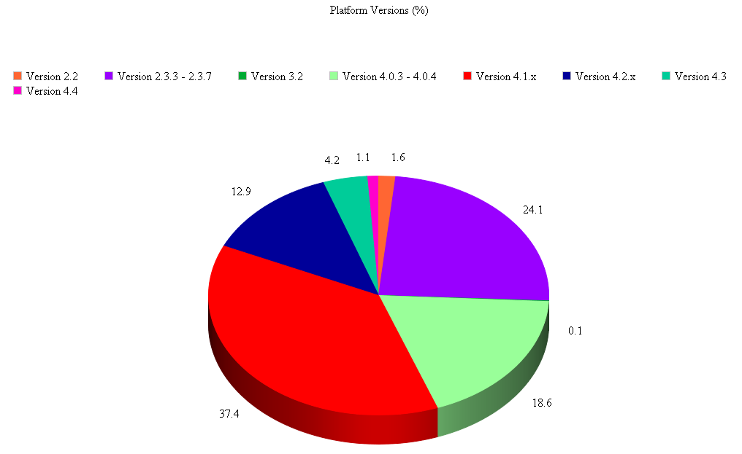

As can be seen from the above data, Version 4.1.x is the dominating version which is being run on devices using the Android platform. For this reason, I will be developing my mobile application to be run on a Samsung Galaxy S3 Mini, which is running version 4.1.2.

### Connecting the Android Application to the MySQL Database

24The most common method for connecting an Android device to a MySQL database is to create a web service which can be used as a medium between them. As MySQL works with the PHP programming language, the easiest way to handle this would be to write a PHP script which will manage the database and this script can then be run using the HTTP protocol on the Android device. The data between Android and PHP can be coded in JSON format by using the JSON functions which are built in to both languages.

The steps which I will be taking in order to make the connection between the Android application and the MySQL database are as follows;

1. Create a Web service in PHP in order to read data from the MySQL Database.
2. Write code for the Android device to connect to the Web service and parse the JSON object.
3. Create PHP code to enable data to be sent to the Web service and save it.
4. Write code for the Android device to send data to the Web service as a JSON object to be saved in the MySQL Database.

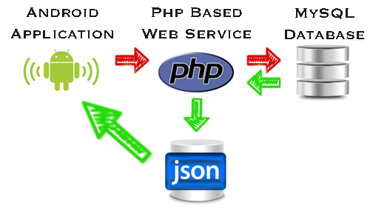

# Use-Case Diagrams

### Online Application

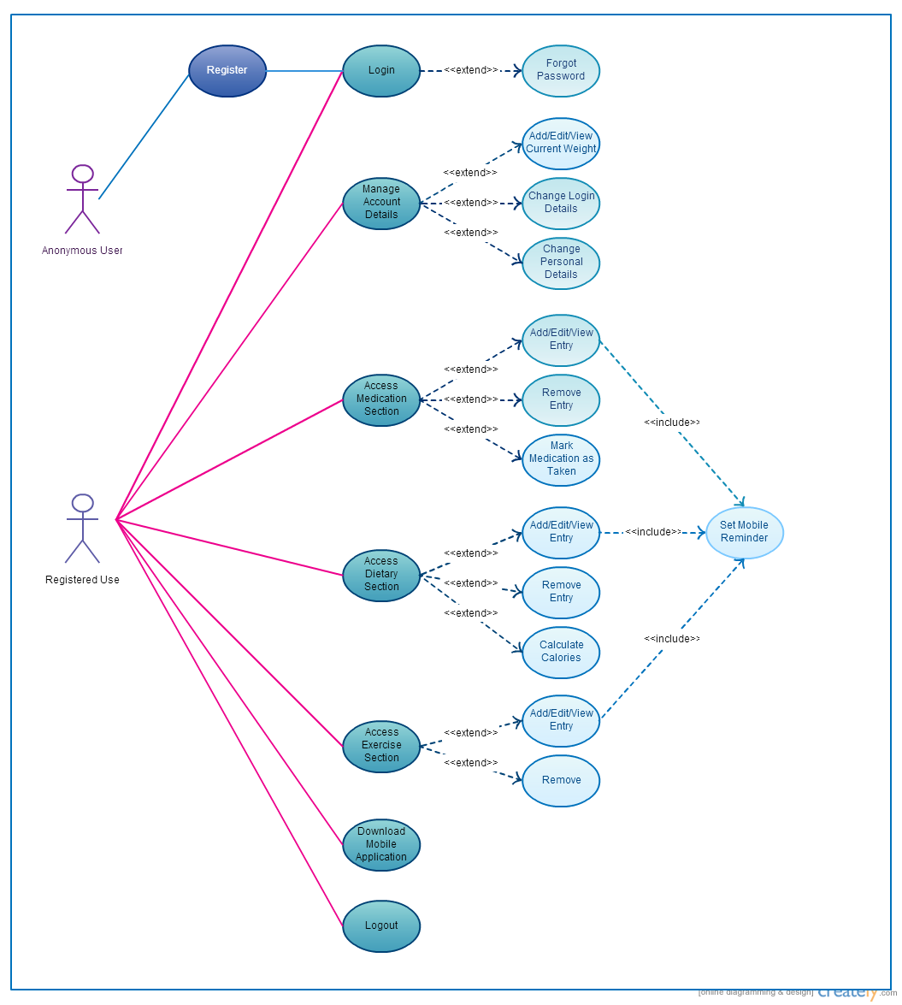

### Mobile Application

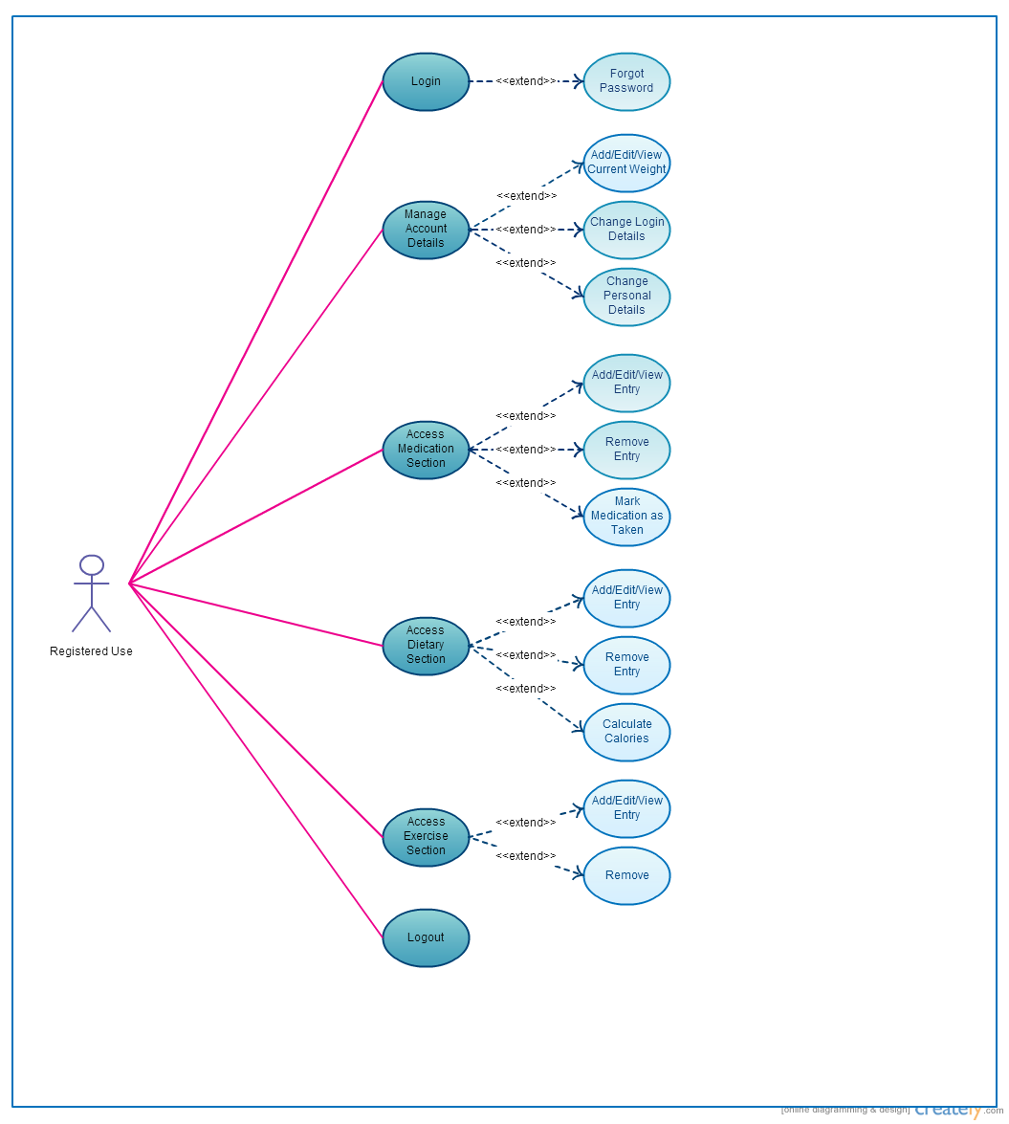

# Requirements

## Functional Requirements (Online Application)

### Registration / Login Page

* The user should be able to fill in the registration form on the main homepage if they have not already created an account.
* To register, the user should have to enter their first name, surname, date of birth, address, e-mail address, user identification, password, the name of their local pharmacy and the pharmacy’s e-mail address.
* Once registered, the user should be able to login with their user identification and password at any time.
* When the user is logging in, they have the option of selecting the “Forgot Password?” link.

### Main Homepage

* Once logged in, the user should be able to enter their current weight.
* The user should have the ability to enter notes regarding their current weight.
* The user should be able to save, delete or edit their current weight and notes (The delete and edit buttons only become active if a record has been saved that day).
* The user should be able to click on a date, on a provided calendar, to view their weight entry and notes on that day or from a previous day.
* The user should be able to print off their current or previous weight record.
* The user should have the option of accessing the medication, dietary or exercise section.
* The user should be able to log out.
* The user should be able to download the mobile application.

### Medication Routine

* The user should be able to enter the name of the medication(s) they are taking, the amount(s) which are to be taken and the time interval at which each dose is to be taken.
* The user should be able to enter the amount which was collected from the pharmacy, before taking any.
* The user should have the option of editing or removing an entry from the list of medication.
* The user should be able to save their updates.
* The user should be able to click on a button which will input general information about the type of medication selected into a provided textbox.
* An automatic e-mail should be sent to the pharmacy when the medication is running low, to have it ordered and ready for collection.
* The user should be able to mark when a dose of medication has been taken.
* The user should be able to print off their current or previous medication list.
* The user should be able to click on a date, on a provided calendar, to view the medication taken on that day.

### Dietary Routine

* The user should be able to select the type of food or drink they consumed as well as selecting the amount consumed. The calories for each entry should then be automatically calculated.
* The user should be able to click the “Calculate” button to add the calories of the food / drink which have already been entered to provide a ‘Total Calorie Intake’. The corresponding food pie chart should also be displayed when this button is clicked.
* The user should have the option of editing or removing an entry from the list of food and drink.
* The user should be able to save their updates.
* The user should be able to print off their current or previous dietary list.
* The user should be able to click on a date, on a provided calendar, to view the food and drink consumed on that day.
* The user should, optionally, be able to enter reminders for the times at which they should eat and, if necessary, what they should be eating.

### Exercise Routine

* The user should be able to enter the amount of time spent exercising per session and select the type of exercising that took place.
* The user should, optionally, be able to enter the times at which they should be exercising on that day to enable the mobile application to remind the user to exercise.
* The user should be able to click on a date, on a provided calendar, to view the exercise routine practiced on that day.
* The user should have the option of editing or removing an entry from the list of exercise practices.
* The user should be able to print off their current or previous exercise list.
* The user should be able to save their updates.

### Administrator Interface

* The pharmacy assistant should be able to register their account using details such as; name, surname, pharmacy name, pharmacy E-mail address, authorised identification number, username and password.
* The pharmacy assistant should be able to login using their administrator identification and their password.
* The pharmacy assistant should be able to manage e-mails which have been received by users about ordering their prescription.
* The pharmacy assistant should be able to send an automatic e-mail back to the user once the prescription is ready for collection.

### Download Mobile Application

* The user should be able to download the mobile application from a link on the homepage of the website.

## Functional Requirements (Mobile Application)

### Login Page

* The user should be able to login using there username and password.
* The user should be able to click the “Sign Up for Lush Lifestyle” link. If the user does click this link, they should be redirected to the Registration Page via the browser.

### Main Homepage

* Once logged in, the user should be able to enter their current weight.
* The user should be able to save, delete or edit their current weight and notes (The delete and edit buttons only become active if a record has been saved that day).
* The user should be able to click on a date, on a provided calendar, to view their weight entry and notes on that day or from a previous day.
* The user should be able to log out.

### Medication Routine

* The user should be able to enter the name of the medication(s) they are taking, the amount(s) which are to be taken and the time interval at which each dose is to be taken.
* The user should be able to view the name of the medication(s) they are taking, the amount(s) which are to be taken and the time(s) at which each dose is to be taken.
* The user should have the option of editing or removing an entry from the list of medication.
* The user should be able to save their updates which will then be sent back to the online application, updating the information displayed there.
* The user should be able to mark when a dose of medication has been taken.
* The user should be able to click on a date, on a provided calendar, to view the medication taken on that day.

### Dietary Routine

* The user should be able to select the type of food or drink they consumed as well as selecting the amount consumed. The calories for each entry should then be automatically calculated.
* The user should be able to view the type of food or drink consumed and the amount consumed.
* The user should have the option of editing or removing an entry from the list of food and drink.
* The user should be able to save their updates which will then be sent back to the online application, updating the information displayed there.
* The user should be able to click on a date, on a provided calendar, to view the food and drink they consumed on that day.

### Exercise Routine

* The user should be able to enter the amount of time spent exercising per session and select the type of exercising that took place.
* The user should be able to view the exercise routine that has already been practised on that day.
* The user should have the option of editing or removing an entry from the exercise routine.
* The user should be able to click on a date, on a provided calendar, to view the exercise routine they practiced on that day.
* The user should be able to save their updates which will then be sent back to the online application, updating the information displayed there.

### Notifications

* The user should be notified by an alarm when they are due to take their medication.
* The user should be notified by an alarm when their prescription has run out and they need to book an appointment with the doctor.
* The user should be notified by an alarm when their total specified calorie intake for the day has been reached.
* The user should be notified when they are supposed to start their exercise routine if they previously provided times at which they would like to begin their exercise routine.
* The user should be notified when they are supposed to eat and what specific food they should have if they previously entered times at which they should be eating.

## Non-Functional Requirements (Online and Mobile Application)

### Look and Feel Requirements

* The website and mobile application should look easy and flexible to navigate around.
* The colour scheme should match on all pages throughout the website and on the mobile application.

### Security and Legal Requirements

The information stored about users should be protected according to the provisions of The Data Protection Act.

# Storyboard

## Online Application

### Registration / Login Page

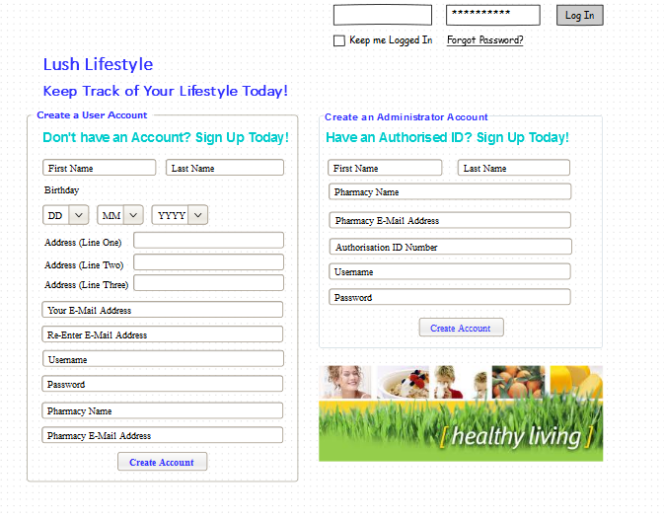

### Main Homepage

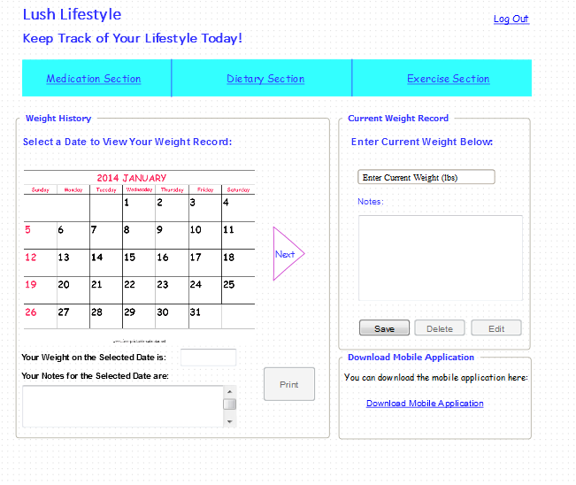

### Medication Section

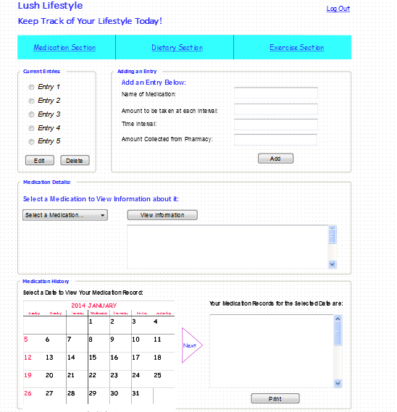

### 

### Dietary Section

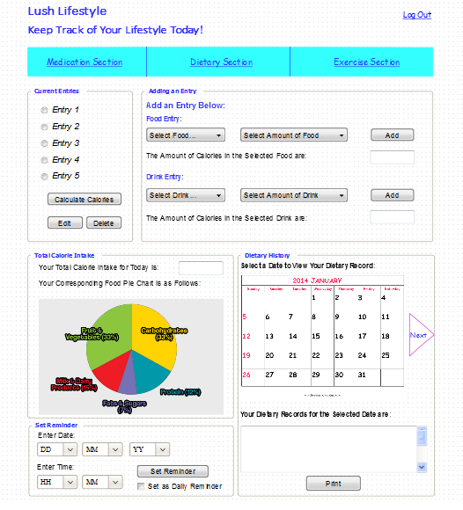

### Exercise Section

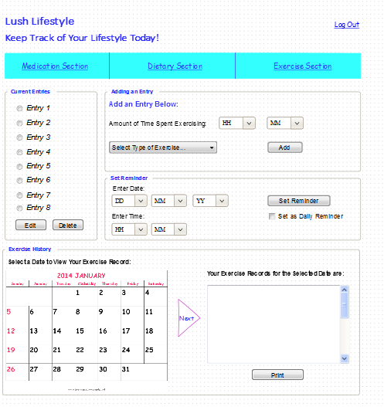

### Administrator Interface

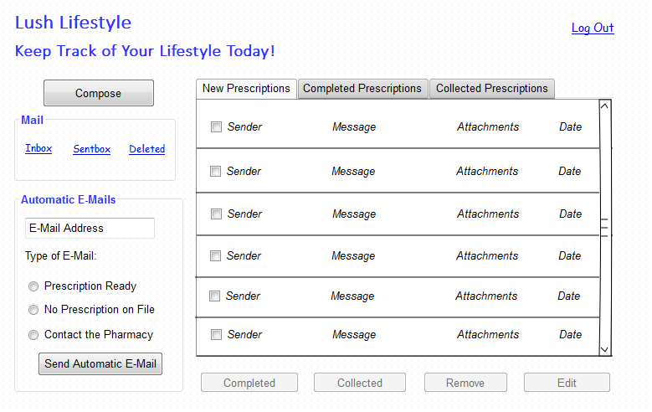Mobile Application

### Login Page

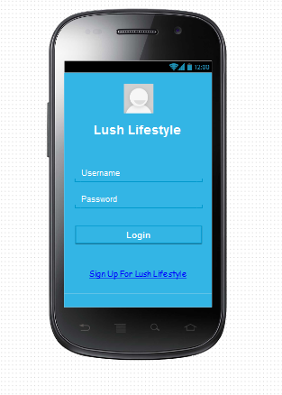

### Main Homepage Medication Section

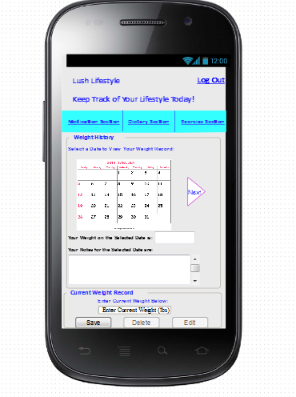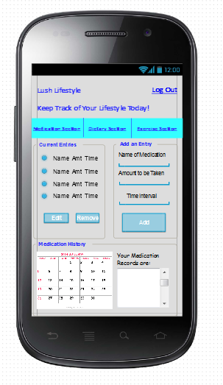

### Dietary Section Exercise Section

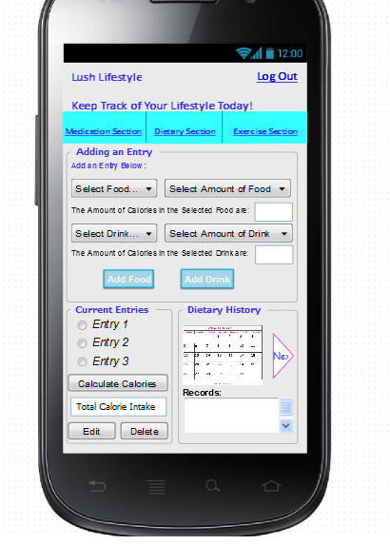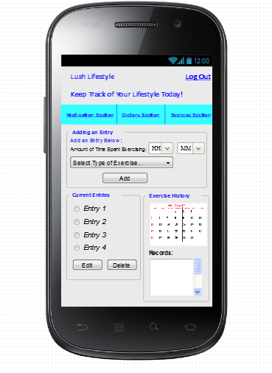

# Project Plan

Below, I have outlined in steps the plan I intend to follow in the implementation phase next semester;

1. Download and install XAMPP 1.8.2, which includes, PHP, Apache Web Server and MySQL Database.
2. Download and install Joomla to be run on the Apache Web Server.
3. Create tables and entries in the database.
4. Design the website using PHP and HTML.
5. Carry out tests and error-checking on the website.
6. Download Eclipse Integrated Development Environment, Java Software Development Toolkit and the Android SDK.
7. Begin to develop the mobile application using the Java programming language.
8. Carry out tests and error checking on the mobile application.
9. Connect the mobile application to the online application by creating a web service which will act as a medium between them.
10. Carry out tests and error checking on the connection.

# Project Schedule

The project schedule outlined below is taking into consideration that, although this project is one of my main priorities for this college year, I also have other college work to attend to. Therefore, time limits will be placed on the amount of time that can be spent on the project alone. The project schedule which I have outlined is as follows;

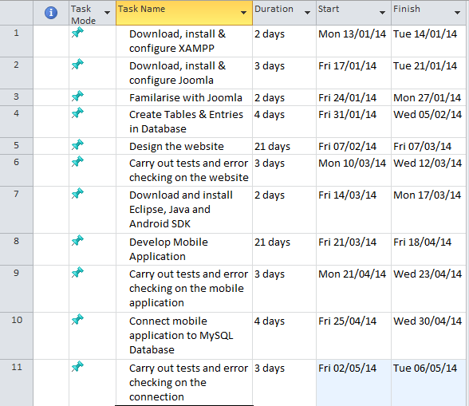

Based on the above schedule, the diagrammatic representation for each month is as follows;

#### January

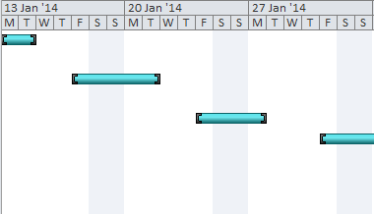

#### February

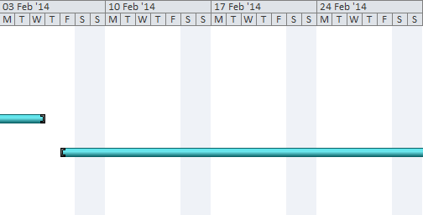

#### March

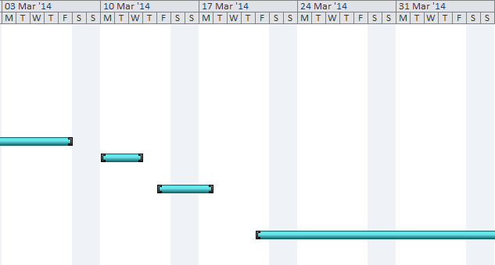

#### April May

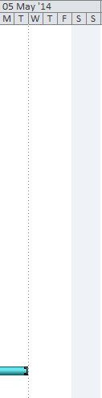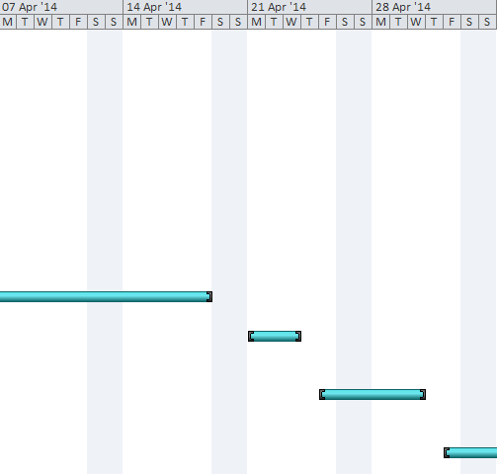

# Conclusion

To conclude, I feel like when I came up with the original medication system, I was slightly nervous about the implementation phase as my level of programming is average, not excellent. But, after carrying out all the necessary research and going through the process step-by-step, I feel much more confident that I can develop an online application which links to an Android mobile application which is for a person seeking assistance on living a healthy lifestyle.

I think the idea of developing a mobile / online application which caters for the needs of people who wish to keep track of their medication, dietary and exercise routines in order to lead a healthier lifestyle, may prove to be a useful idea. I intend to create the application to allow it to be easy-to-use, as a lot of applications developed today require the user to have at least an average level of computer skill. But, I know many people who would be interested in using my application, yet, they do not have a lot of experience with technology devices, if any.

I decided to use XAMPP as my solution stack to make the process slightly more manageable. As this includes PHP, Apache and MySQL, the process becomes simplified and faster; this is exactly what I require as I do not have a lot of time to complete the implementation phase due to the requirement of other college work to be completed. Once I have XAMPP installed, I will be installing Joomla on the web server. I chose Joomla as I have had a small amount of previous experience with it and I would like to investigate it further.

In relation to the mobile application, I decided to develop it using an Android device for reasons outlined earlier in the document. The fact that the online application is linked to the mobile application is the main aspect of the project which differentiates it from other dietary, medication and exercise planning applications that can be found online. During my research, I did not come across an online / mobile application that records as well as reminds the user of their medication requirements, dietary intake routine and exercise expectations.

Honestly, I was not sure how I would go about linking my mobile application to the MySQL database so that both applications are retrieving and sending the same data. But after a few hours of study and research, I discovered the best way to do this was by creating a web service which acts almost like an medium between the device and the database. I found a few webpages which seemed helpful in relation to writing the PHP code to develop this web service, I now feel more confident about this section of the project also.

I created one section within my document which I intended to be used for mostly diagrams. I began by outlining my use-case diagrams. These visually describe what the user can do on the online system as well as the mobile system. I then carried on developing a storyboard. This is basically used to give the readers of my project, as well as myself, a visually idea in their mind as to what I believe the website and mobile application should look like in terms of design. These allow the readers to interpret the design I have made out in my mind.

Finally, I ended my project by outlining the project plan, or in other words, the actions I intend to take in the implementation phase. I realise these steps were basic and brief, because I will be developing on these steps in the document I have to write for the next phase. Also, I used Microsoft Project to design a Gantt chart to portray the time I expect to spend developing the applications. The times which I allocated myself are spread out and reasonable, this is because I have to take other college work into consideration.

# 

# Bibliography

1. Content management system - Wikipedia, the free encyclopaedia. 2013. Content management system - Wikipedia, the free encyclopaedia. [ONLINE] Available at: <http://en.wikipedia.org/wiki/Content_management_system>. [Accessed 18 November 2013].
2. Types of CMS. 2013. Types of CMS. [ONLINE] Available at: <http://www.cms.co.uk/types/>. [Accessed 18 November 2013].
3. What is Joomla? 2013. What is Joomla? [ONLINE] Available at: <http://www.joomla.org/about-joomla.html>. [Accessed 22 November 2013].
4. Wordpress › About. 2013. Wordpress › About. [ONLINE] Available at: <http://wordpress.org/about/>. [Accessed 22 November 2013].
5. What is Drupal? | Learn What Drupal Can Do for Your Website | Acquia. 2013. What is Drupal? | Learn What Drupal Can Do for Your Website | Acquia. [ONLINE] Available at: <http://www.acquia.com/what-is-drupal>. [Accessed 22 November 2013].
6. Mobile application development - Wikipedia, the free encyclopaedia. 2013. Mobile application development - Wikipedia, the free encyclopaedia. [ONLINE] Available at: <http://en.wikipedia.org/wiki/Mobile_application_development#Platform_development_environment>. [Accessed 25 November 2013].
7. Android Application Development Outsourcing. 2013. Android Application Development Outsourcing. [ONLINE] Available at: <http://www.androidoutsourcing.com/advantage-of-android-platform.html>. [Accessed 25 November 2013].
8. Disadvantages of Android - The Best Book on Finding & Developing Your Android App Idea. 2013. Disadvantages of Android - The Best Book on Finding & Developing Your Android App Idea. [ONLINE] Available at: <http://www.hyperink.com/Disadvantages-Of-Android-b94a25>. [Accessed 25 November 2013].
9. Advantages of BlackBerry 10 App Development |. 2013. Advantages of BlackBerry 10 App Development |. [ONLINE] Available at: <http://postbloggers.com/advantages-of-blackberry-10-app-development/>. [Accessed 25 November 2013].
10. The Advantages and Disadvantages of Blackberry App Development - Best Articles Submission. 2013. The Advantages and Disadvantages of Blackberry App Development - Best Articles Submission. [ONLINE] Available at: <http://bestarticles.com/the-advantages-and-disadvantages-of-blackberry-app-development&id=26573>. [Accessed 25 November 2013].
11. What are the Pros and Cons to Building an App for iOS? | Kinvey Backend as a Service Blog. 2013. What are the Pros and Cons to Building an App for iOS? | Kinvey Backend as a Service Blog. [ONLINE] Available at: <http://www.kinvey.com/blog/2360/what-are-the-pros-and-cons-to-building-an-app-for-ios>. [Accessed 25 November 2013].
12. The Real Reason Windows Phone Is Failing – ReadWrite. 2013. The Real Reason Windows Phone Is Failing – ReadWrite. [ONLINE] Available at: <http://readwrite.com/2013/04/04/the-real-reason-windows-phone-is-failing#awesm=~opE1kWdBgm5vJh>. [Accessed 25 November 2013].
13. Windows Phone, Android Gain Market Share While Apple Slips Despite Growth In iPhone Shipments | TechCrunch. 2013. Windows Phone, Android Gain Market Share While Apple Slips Despite Growth In iPhone Shipments | TechCrunch. [ONLINE] Available at: <http://techcrunch.com/2013/11/12/windows-phone-android-gain-market-share-while-apple-slips-despite-growth-in-iphone-shipments/>. [Accessed 25 November 2013].
14. What is Java Development Kit (JDK)? - Definition from WhatIs.com. 2013. What is Java Development Kit (JDK)? - Definition from WhatIs.com. [ONLINE] Available at: <http://searchsoa.techtarget.com/definition/Java-Development-Kit>. [Accessed 29 November 2013].
15. An Introduction to the Eclipse IDE - O'Reilly Media. 2013. An Introduction to the Eclipse IDE - O'Reilly Media. [ONLINE] Available at: <http://www.onjava.com/pub/a/onjava/2002/12/11/eclipse.html>. [Accessed 29 November 2013].
16. What is Android SDK? - Definition from Techopedia . 2013. What is Android SDK? - Definition from Techopedia . [ONLINE] Available at: <http://www.techopedia.com/definition/4220/android-sdk>. [Accessed 29 November 2013].
17. Dashboards | Android Developers. 2013. Dashboards | Android Developers. [ONLINE] Available at: <http://developer.android.com/about/dashboards/index.html>. [Accessed 29 November 2013].
18. What is XAMPP? | Knowledgement from Target Integration. 2013. What is XAMPP? | Knowledgement from Target Integration. [ONLINE] Available at: <http://www.knowledgement.ie/technical/programming/what-is-xampp>. [Accessed 01 December 2013].
19. apache friends - xampp for windows. 2013. apache friends - xampp for windows. [ONLINE] Available at: <http://www.apachefriends.org/en/xampp-windows.html>. [Accessed 01 December 2013].
20. Apache Server Definition. 2013. Apache Server Definition. [ONLINE] Available at: <http://www.modulehosting.com/apache.html>. [Accessed 01 December 2013].
21. Welcome! - The Apache HTTP Server Project. 2013. Welcome! - The Apache HTTP Server Project. [ONLINE] Available at: <http://httpd.apache.org/>. [Accessed 01 December 2013].
22. What is a MySQL Database?. 2013. What is a MySQL Database?. [ONLINE] Available at: <http://www.host-shopper.com/what-is-a-mysql-database.html>. [Accessed 01 December 2013].
23. What is PHP, and why do I need it?. 2013. What is PHP, and why do I need it?. [ONLINE] Available at: <http://www.homeandlearn.co.uk/php/php1p1.html>. [Accessed 01 December 2013].
24. Connecting to MySQL database | Hello Android. 2013. Connecting to MySQL database | Hello Android. [ONLINE] Available at: <http://www.helloandroid.com/tutorials/connecting-mysql-database>. [Accessed 02 December 2013].